Chapter 17, Solution 15.

(a) Dcos ωt + Esin ωt = A cos(ωt - θ)

where A = 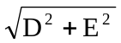, θ = tan⁻¹(E/D)

A = 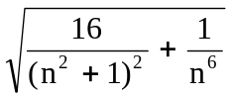, θ = tan⁻¹((n²+1)/(4n³))

f(t) = 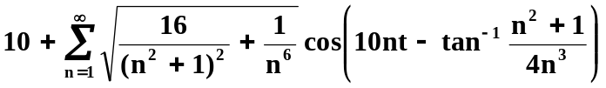

(b) Dcos ωt + Esin ωt = A sin(ωt + θ)

where A = , θ = tan⁻¹(D/E)

f(t) = 